1. Create user Techie and provide sudo access

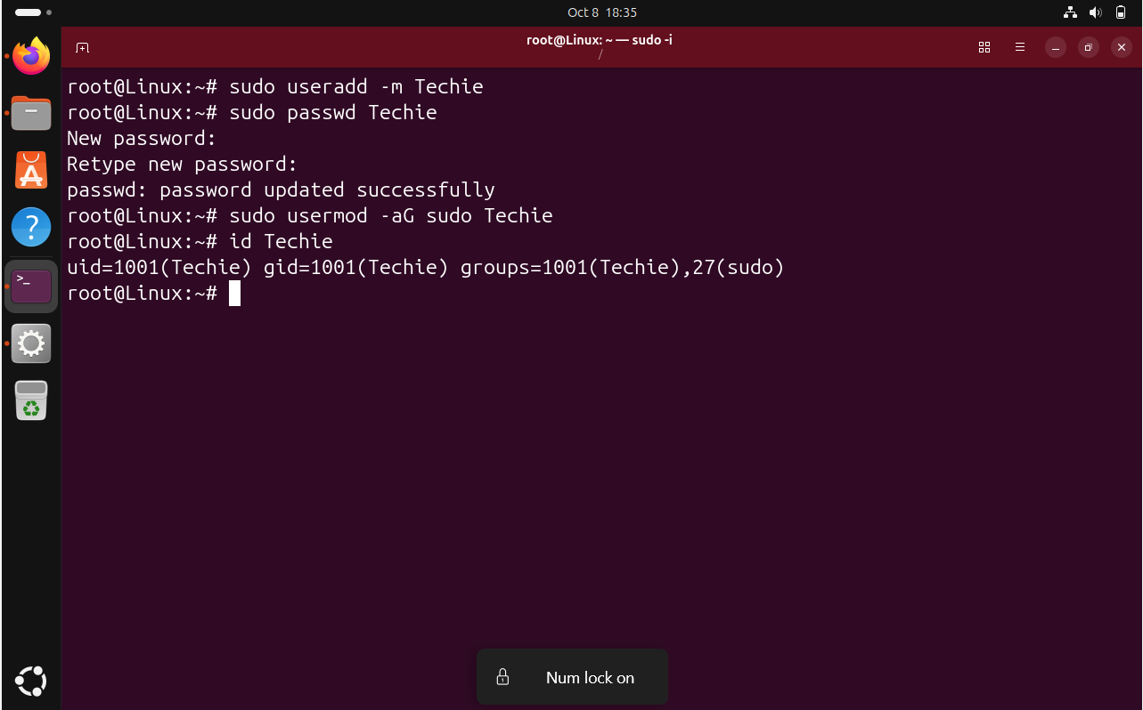

I created a new user named Techie and assigned a password. I added the user to the sudo group so that Techie can perform administrative operations.

2. Navigate to the home directory

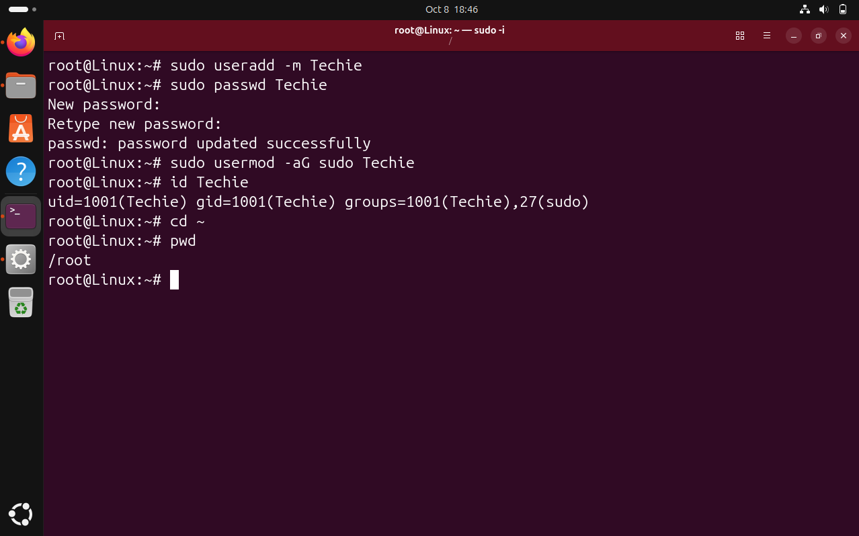

I used the cd command to navigate to the home directory of the current user.

3. Create a new directory.
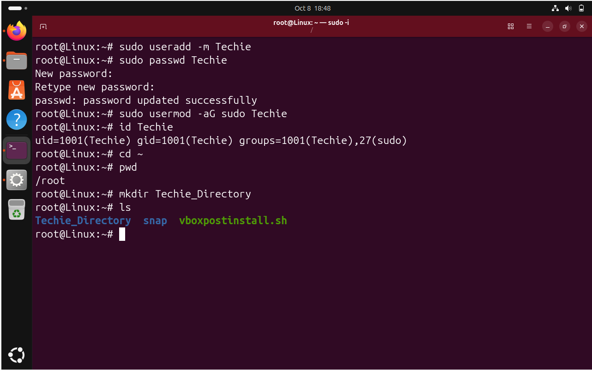

I used the mkdir command to create a new directory named Techie_Directory

4. List the contents of a directory.

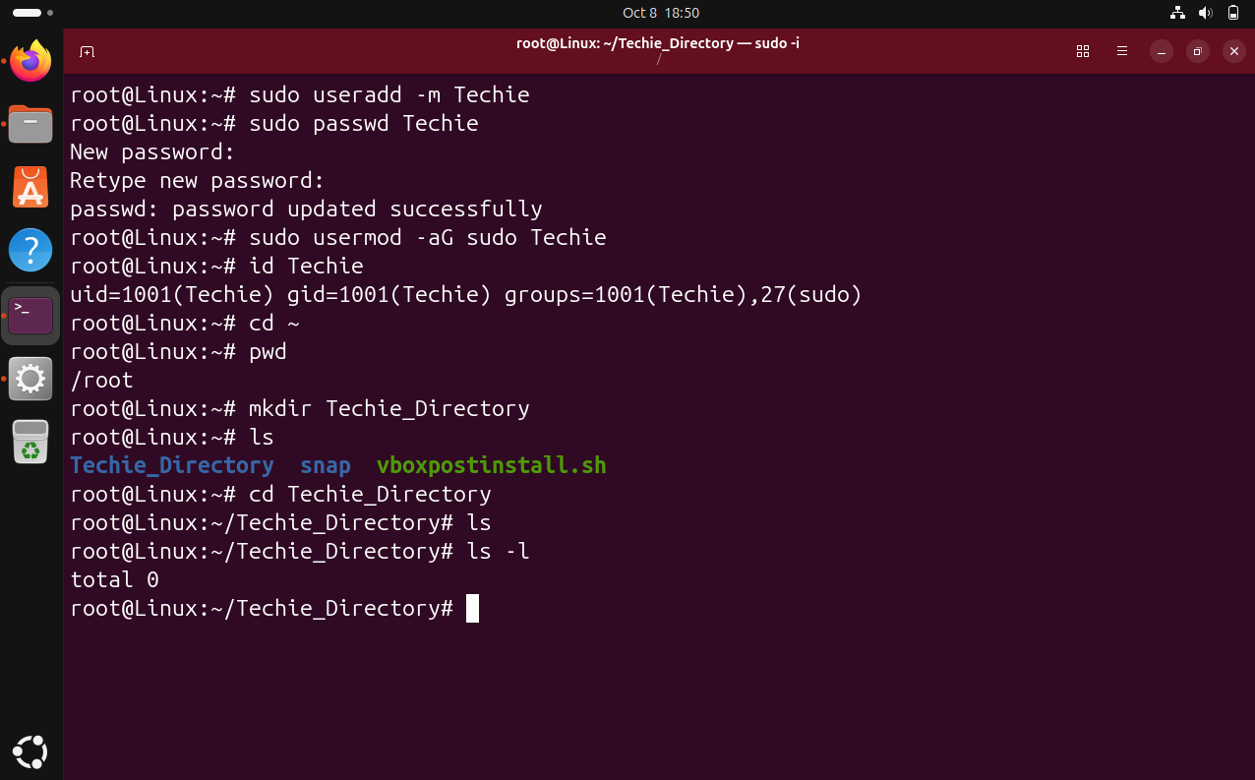

I used the ls command to list the files and directories available in the current directory.

5. Change the current directory

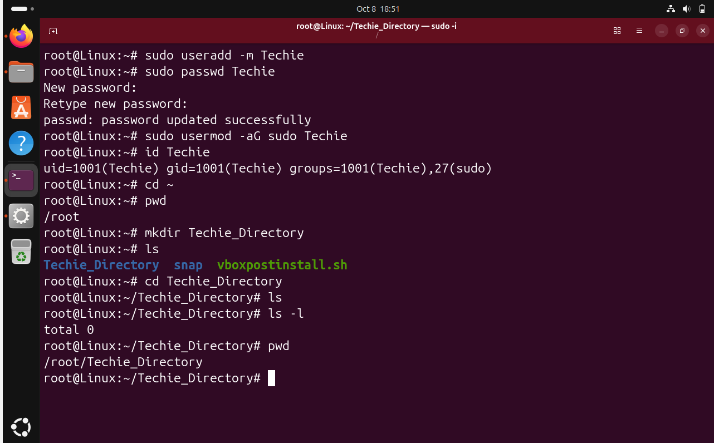

I used the cd command to change from the current directory to Techie_Directory.

6. Create a new empty file
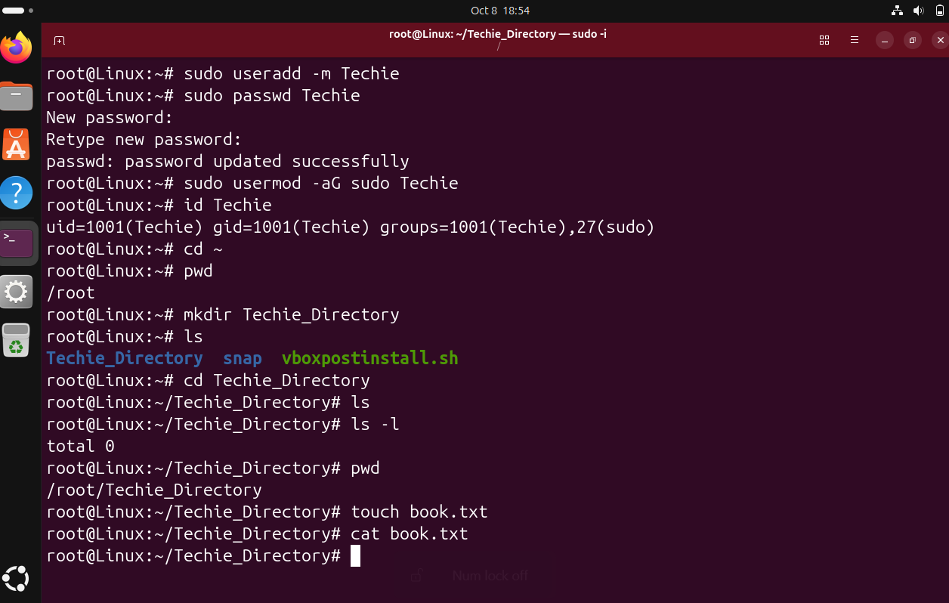

I used the touch command to create a new empty file named book.txt.

7. View the contents of a file
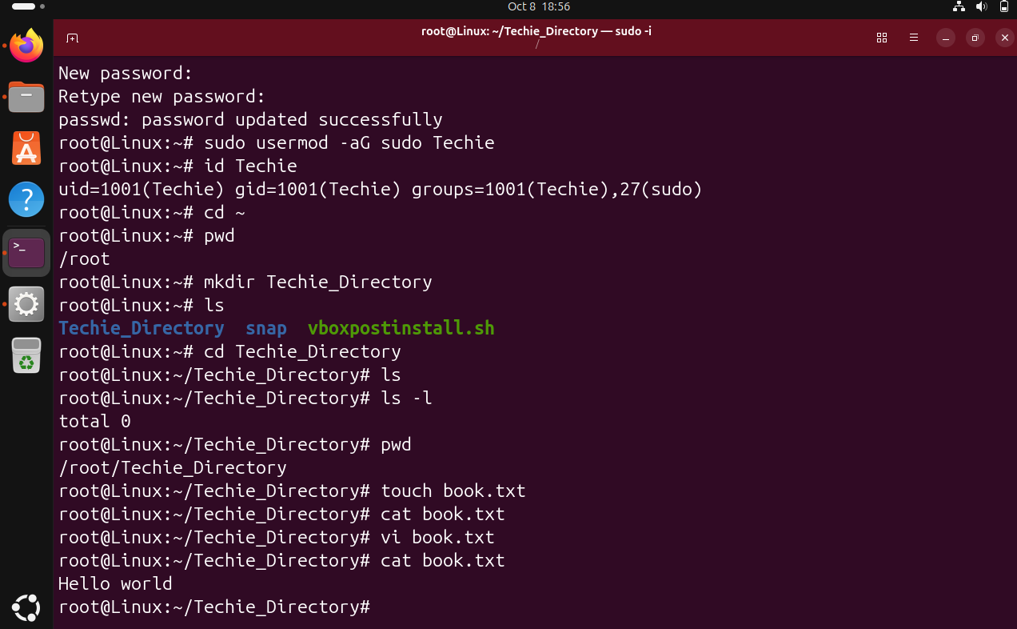

I used the cat command to display the contents of book.txt on the terminal.

8. Copy a file to another location

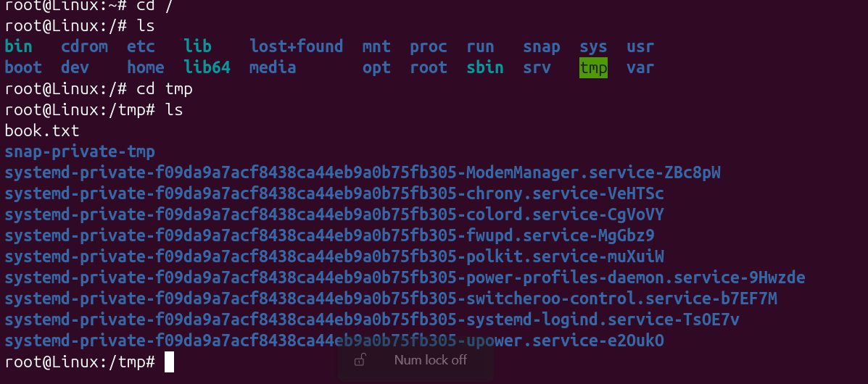

I used the cp command to create a copy of book.txt and place it in the /tmp directory.
9. Move a file to another location

mv test.txt /home/

I used the mv command to move book.txt from the current directory to the /home directory.
10. Rename a file
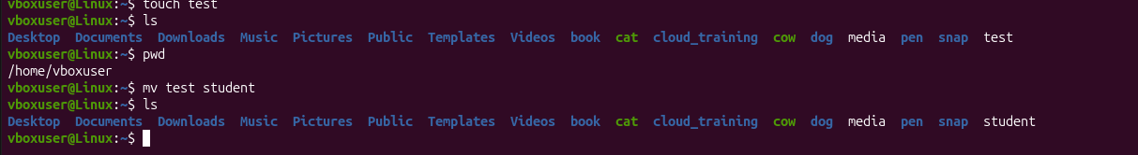
I used the mv command to rename test to student.

11. Delete a file
I used the rm command to permanently delete the specified file.

12. Grant or revoke permissions on a file or directory

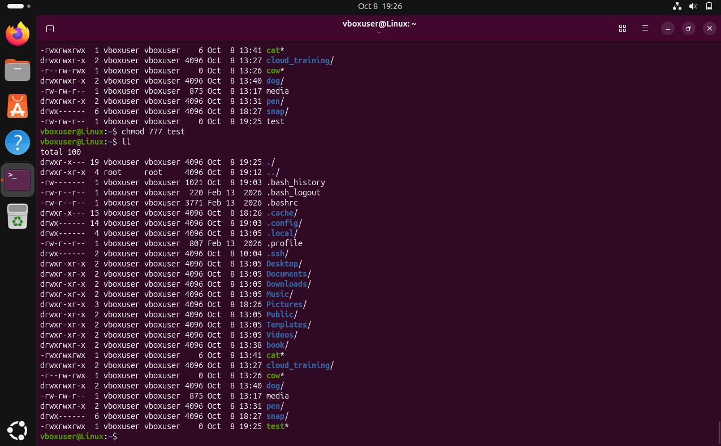

I used the chmod command to modify the permissions of a file or directory. It can be used to grant or remove read, write, and execute permissions.
13. View the current date and time
I used the date command to display the current system date, time, and timezone.

14. Check system uptime

I used the uptime command to check how long the system has been running since the last boot.

15. View running processes

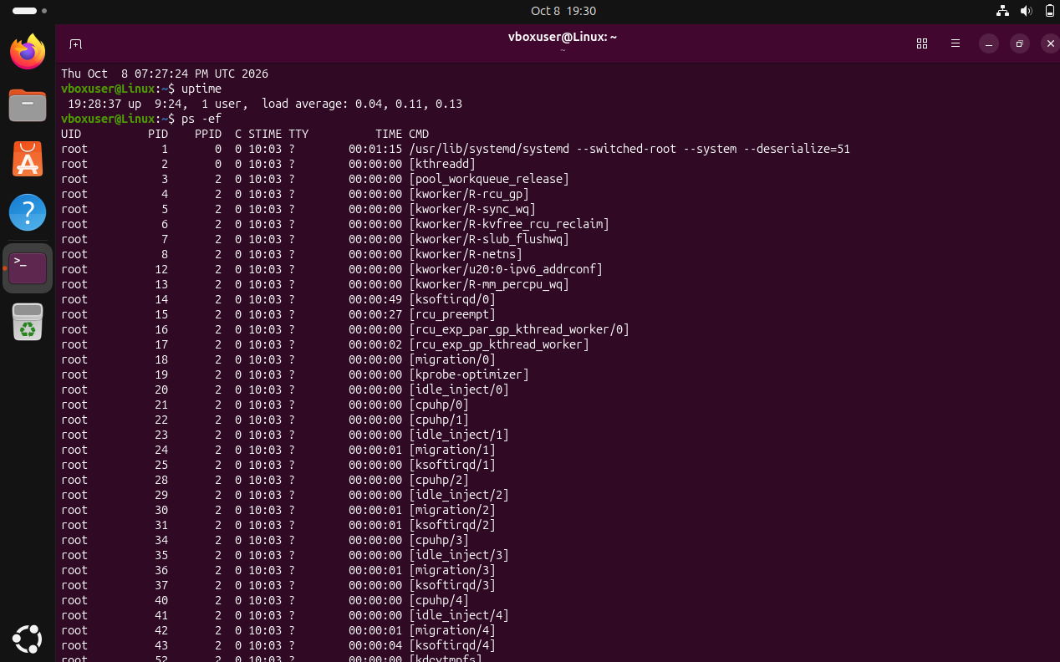

I used the ps -ef command to display the currently running processes along with their process IDs and other details.

16. Kill a running process

I identified the Process ID (PID) and used the kill command to terminate the process.

17. Install a package using the package manager

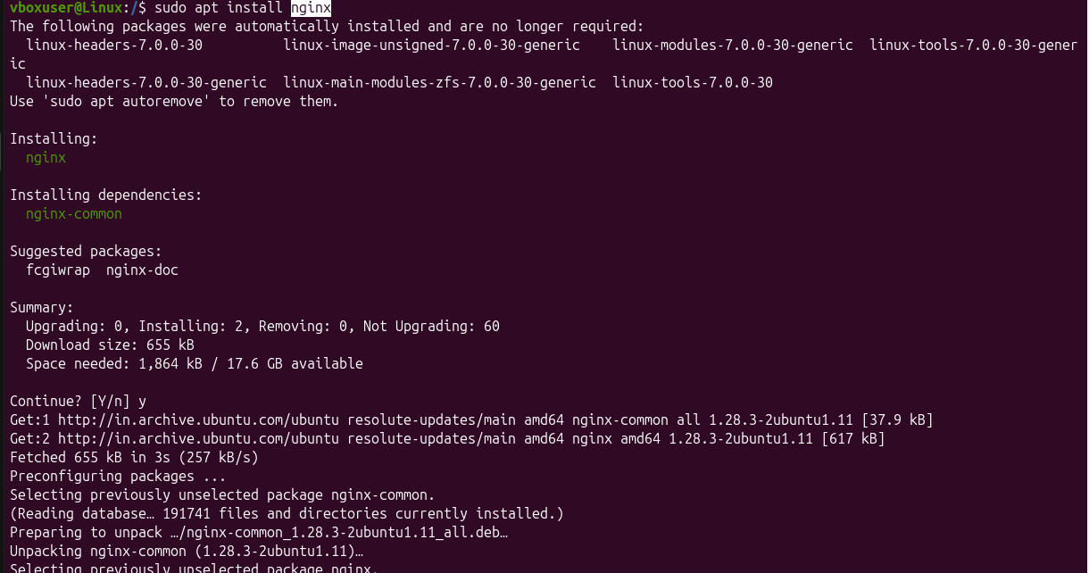

I used the apt package manager to install the Nginx package on the Ubuntu system.

18. Update system packages

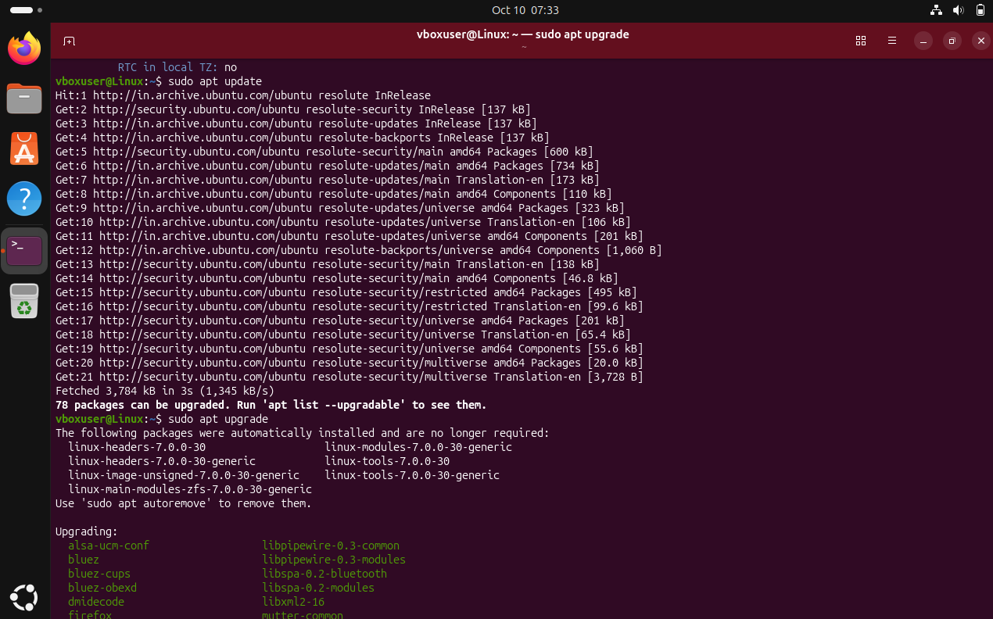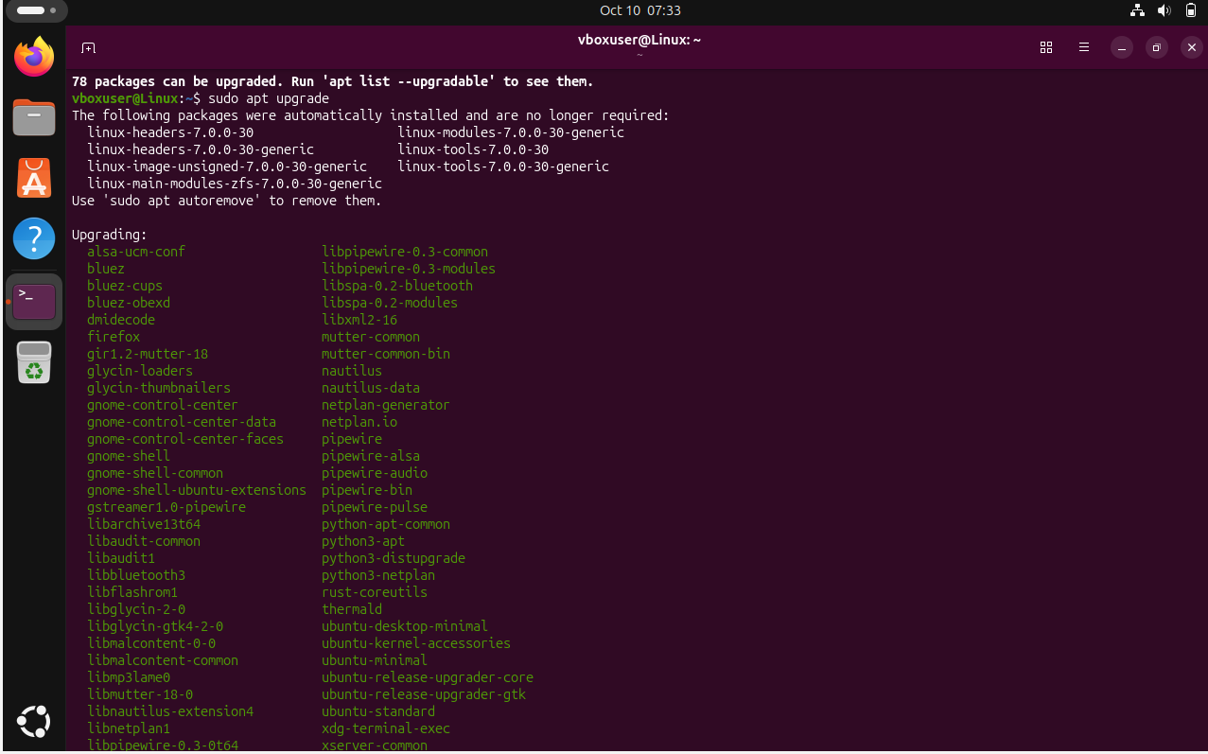

I used apt update to refresh the package information and apt upgrade to install available package updates.

19. Create a symbolic link
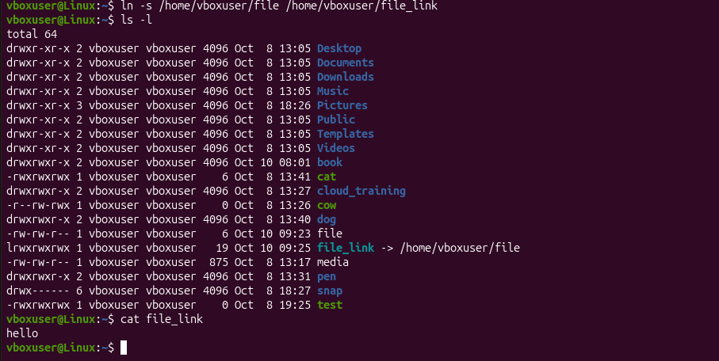

I used ln -s to create a symbolic link pointing to the original file. The symbolic link acts as a reference to the original file.
20. Search for files using find
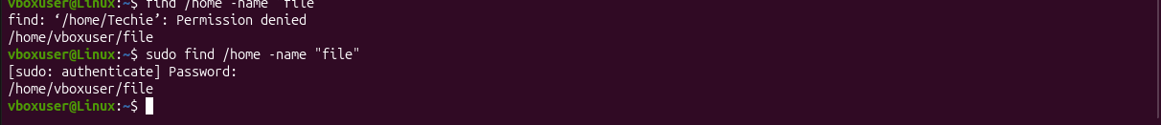
I used the find command to search for a file named test.txt inside the /home directory.

21. Compress and decompress files using tar

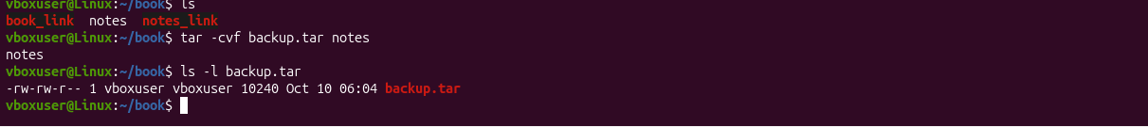

I used tar -cvf to create an archive containing the file. I used tar -xvf to extract the files from the archive.



22. Monitor system resources

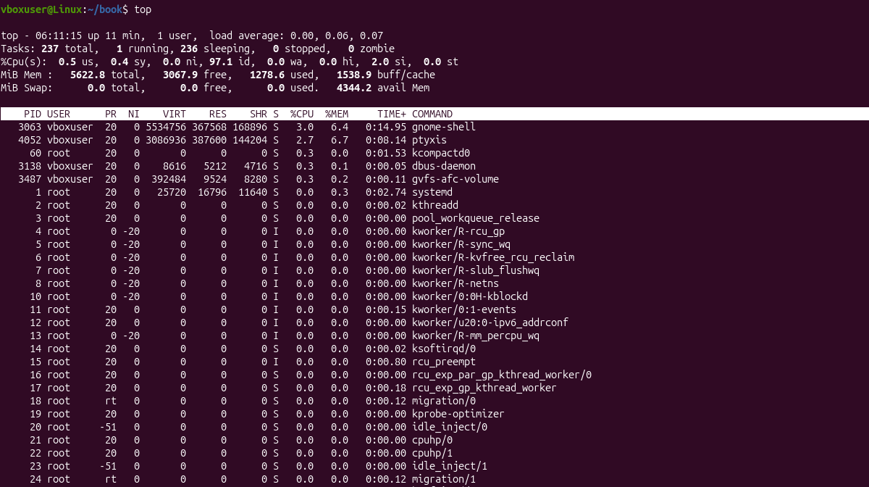

I used the top command to monitor CPU usage, memory usage, load average, and running processes in real time.

23. Create and manage user groups

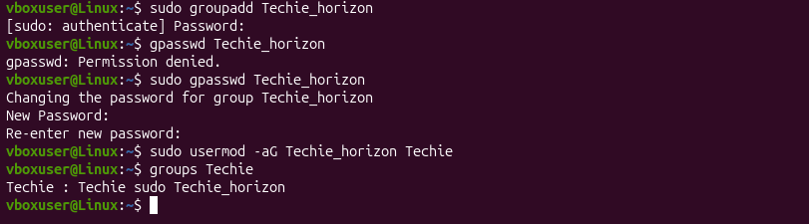

I created a Techie_horizon group and added the Techie user to it. Groups help manage permissions for multiple users.
24. Set up SSH passwordless authentication

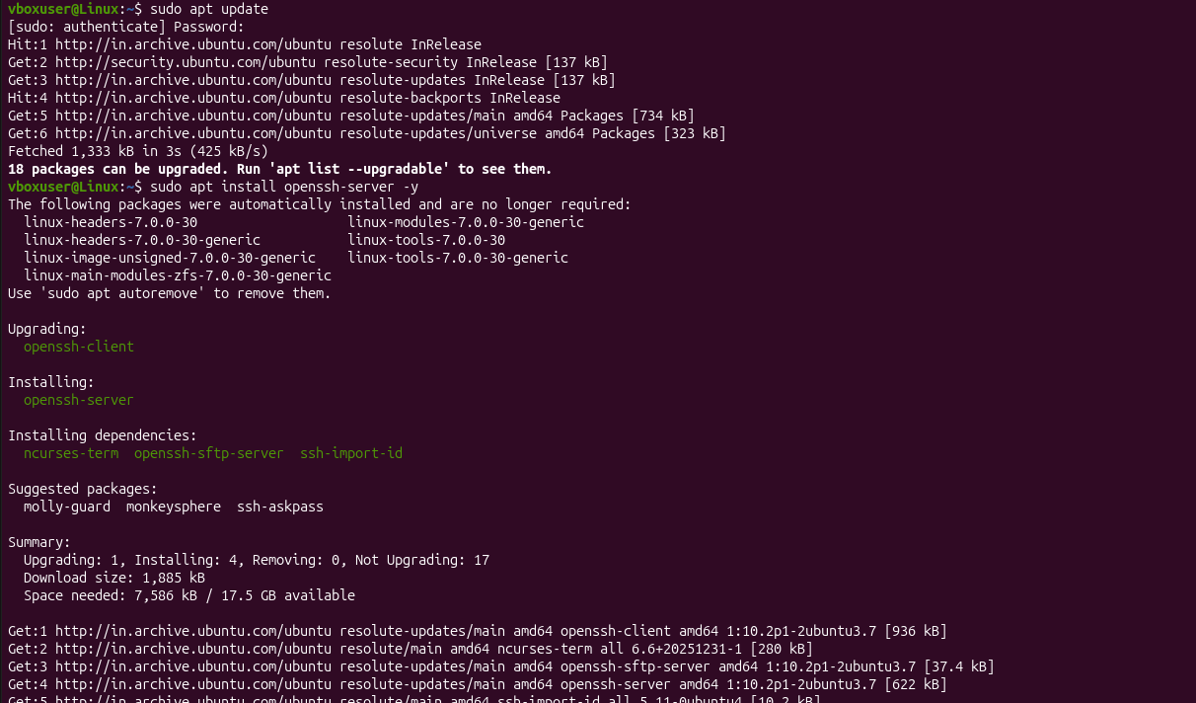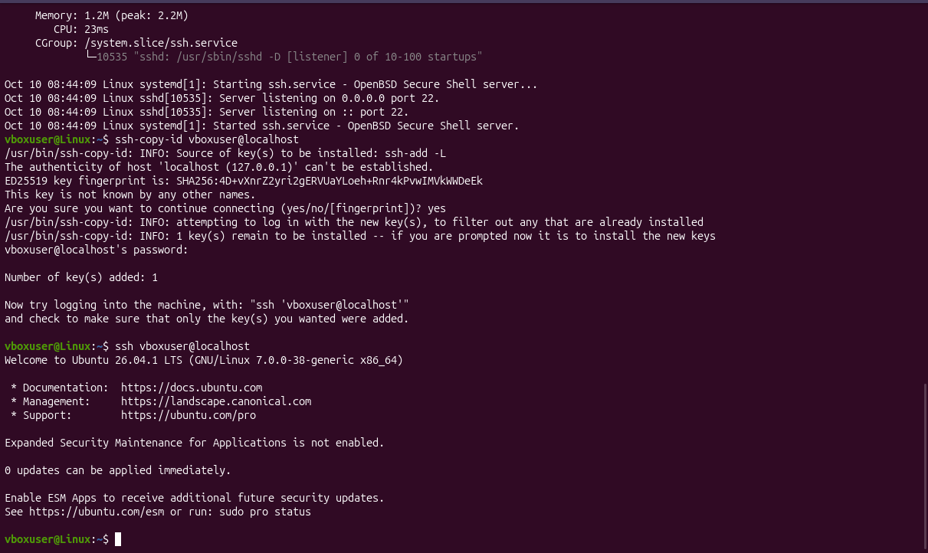

I installed and configured the OpenSSH server on Ubuntu and generated SSH keys for authentication. I copied the public key to the authorized_keys file and successfully tested passwordless SSH login using ssh vboxuser@localhost.

25. Monitor log files using tail or grep

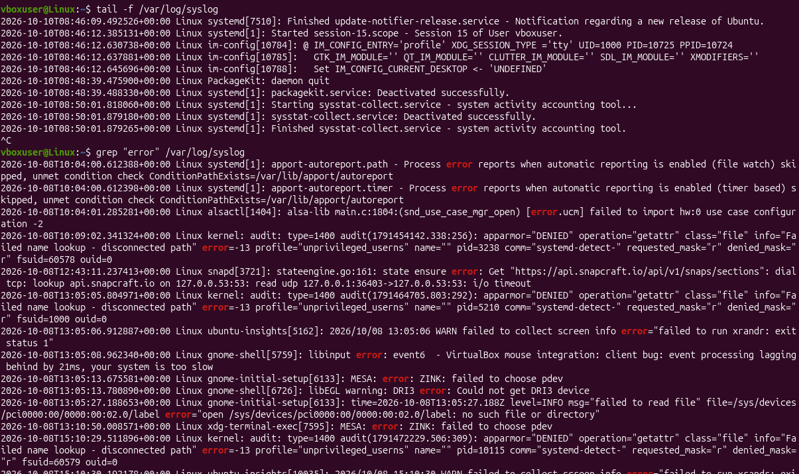

I used tail -f to monitor new log entries in real time. I used grep to search the log file for a specific pattern such as error.

26. Set up a web server – Nginx
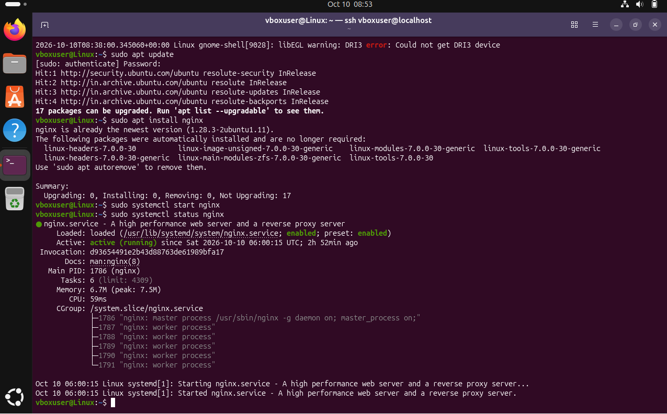
I installed and started the Nginx web server. I used systemctl status to verify whether the service is running.
27. Configure and secure MySQL database
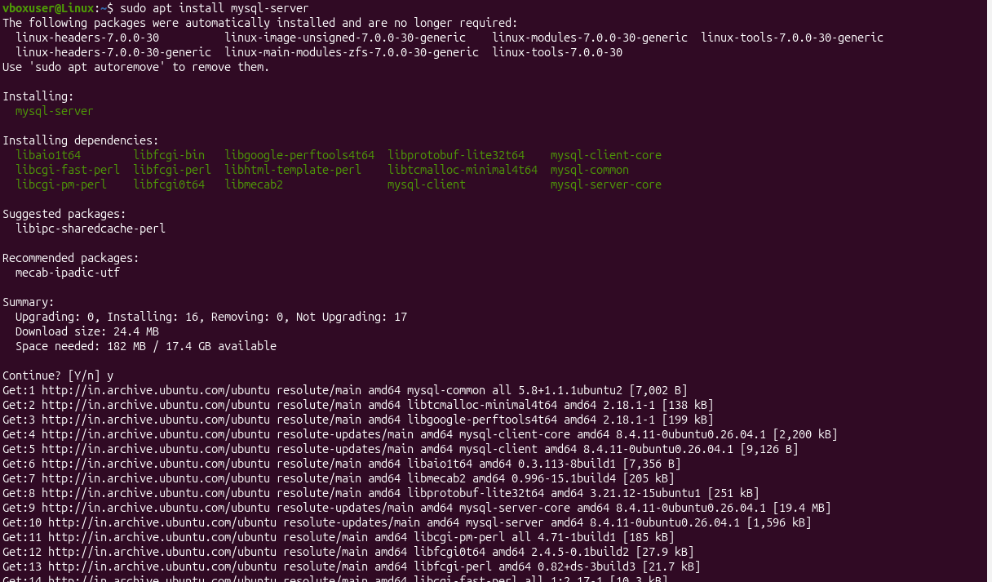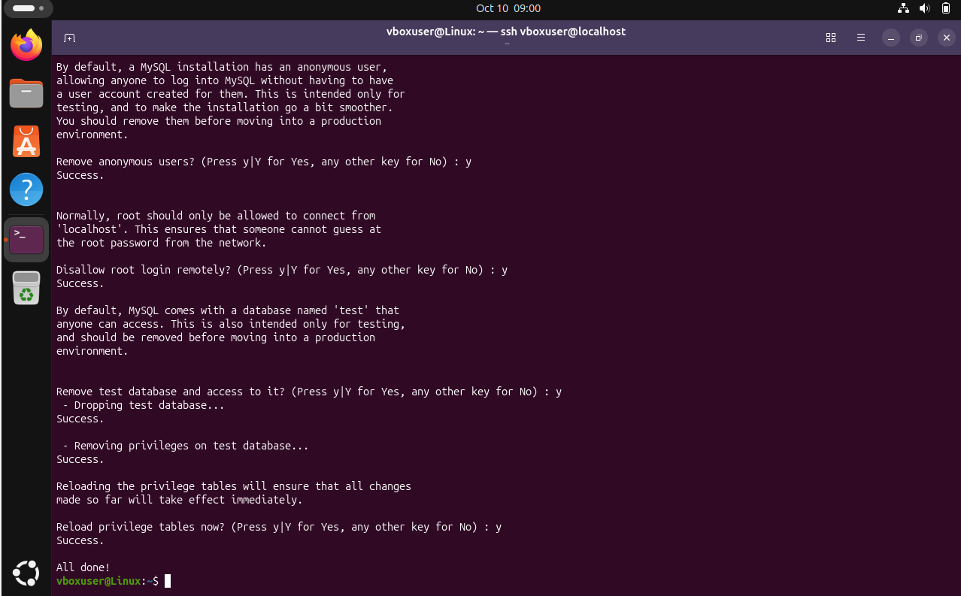

I installed MySQL and started the database service. I used mysql_secure_installation to perform basic security configuration such as removing unnecessary/default setting
28. Set up an Application Server – Apache Tomcat

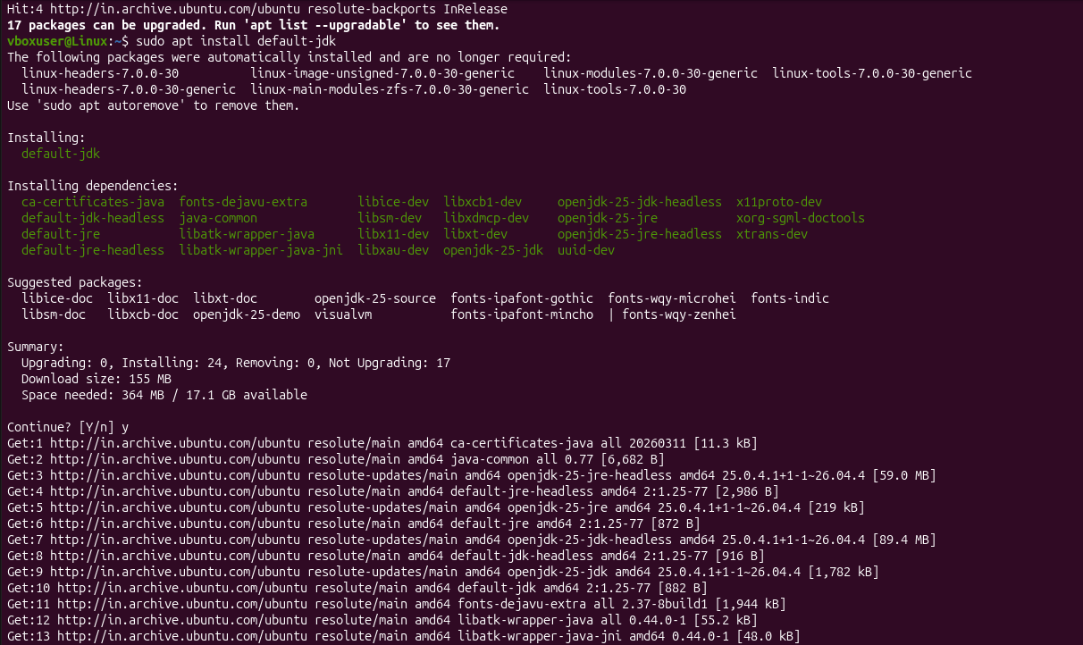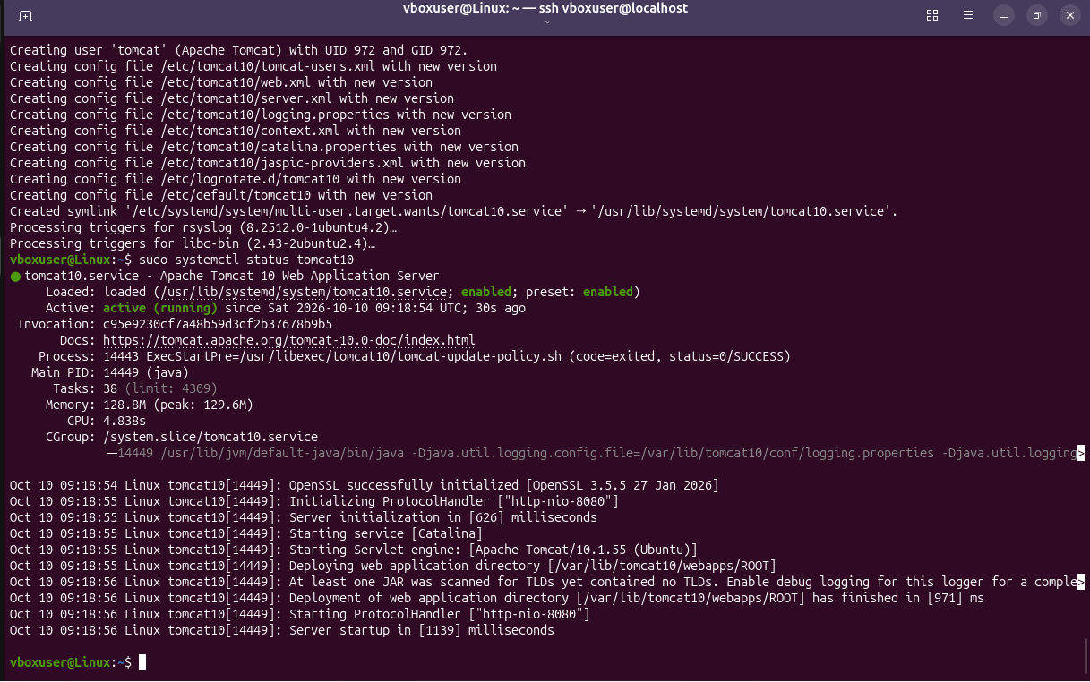

I installed Java as the required runtime and configured Apache Tomcat as the application server. I started Tomcat and verified that its process was running.

29. Create a service file for Apache Tomcat

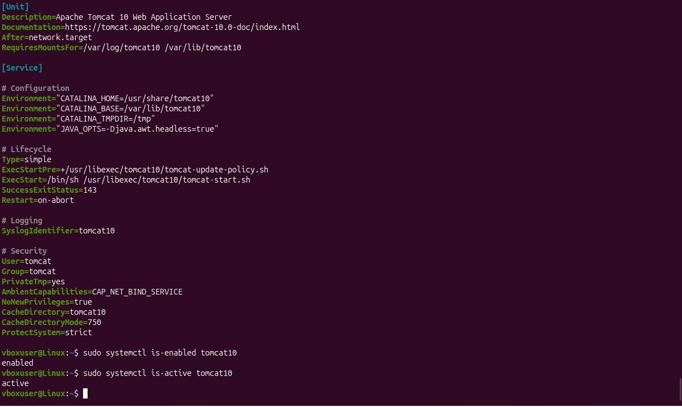

I created a systemd service file for Apache Tomcat so that Tomcat can be managed using systemctl. I can start, stop, restart, enable, and check the Tomcat service using systemd.
30. Print specific columns from a delimited file


31. Filter and print lines based on a pattern/condition

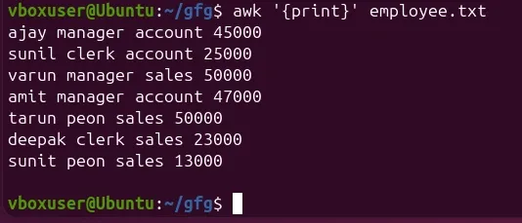
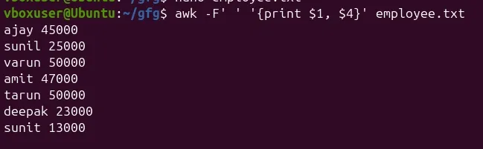
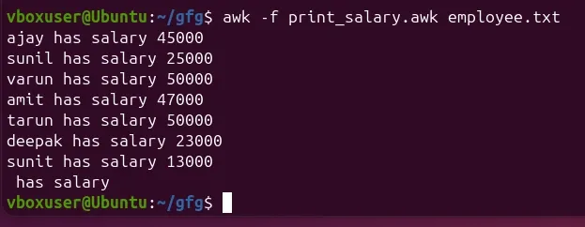

32. Calculate average, sum, or statistics of a column

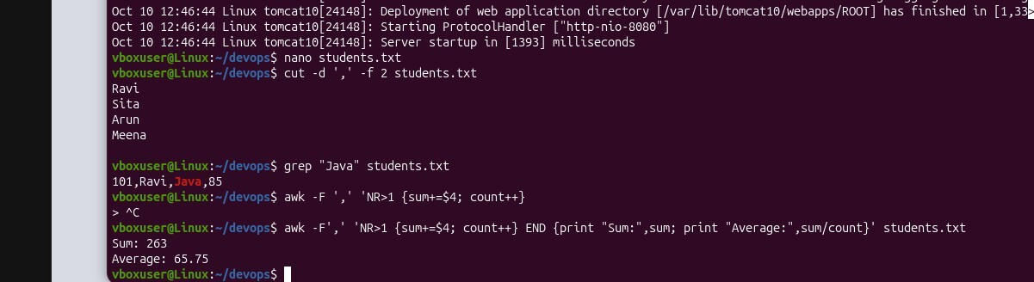

33. Perform string manipulation

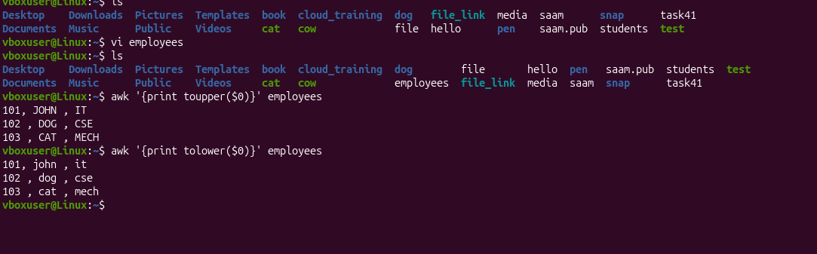
34. Count occurrences of a specific pattern

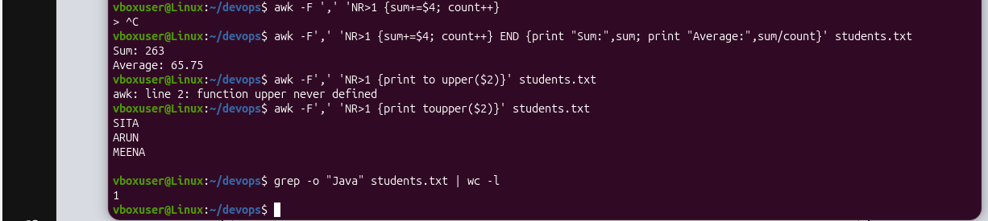

35. Sort lines based on a specific field/column

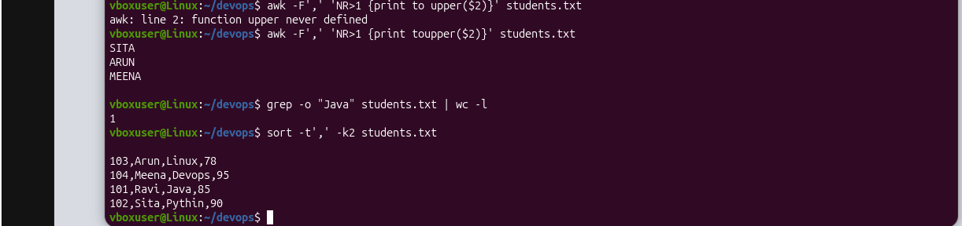

36. Merge multiple files based on a common field/column
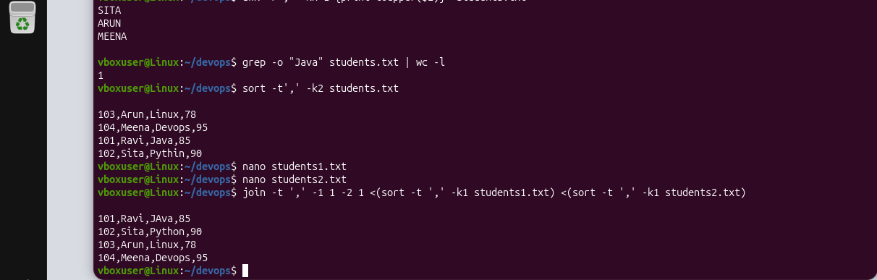

37. Substitute text using search and replace

I used sed to search for the word Linux and replace it with Ubuntu. The g option replaces all occurrences in each line.

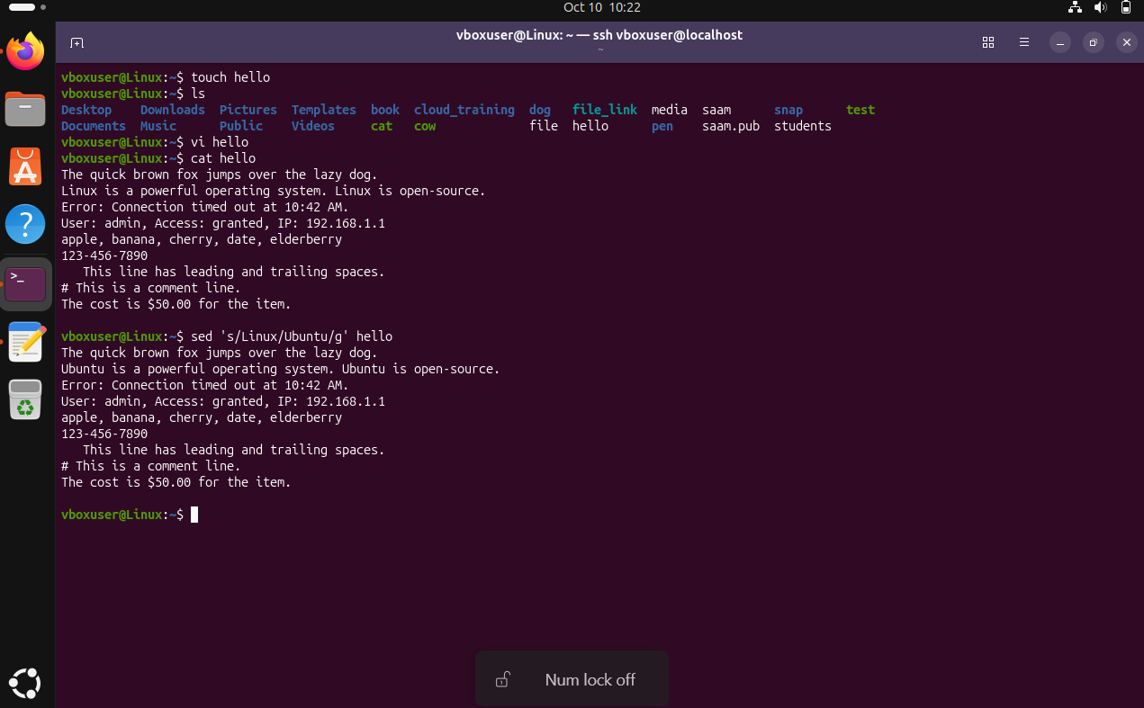

38. Delete specific lines based on pattern or line number

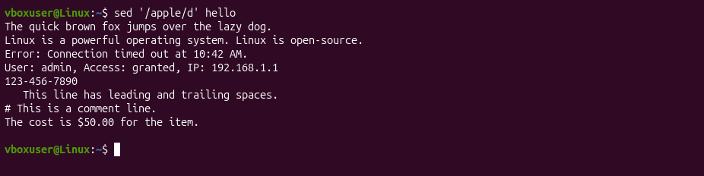

I used sed with the d command to delete specific lines. The line can be selected using its line number or a matching pattern.

39. Append or insert text before/after a pattern

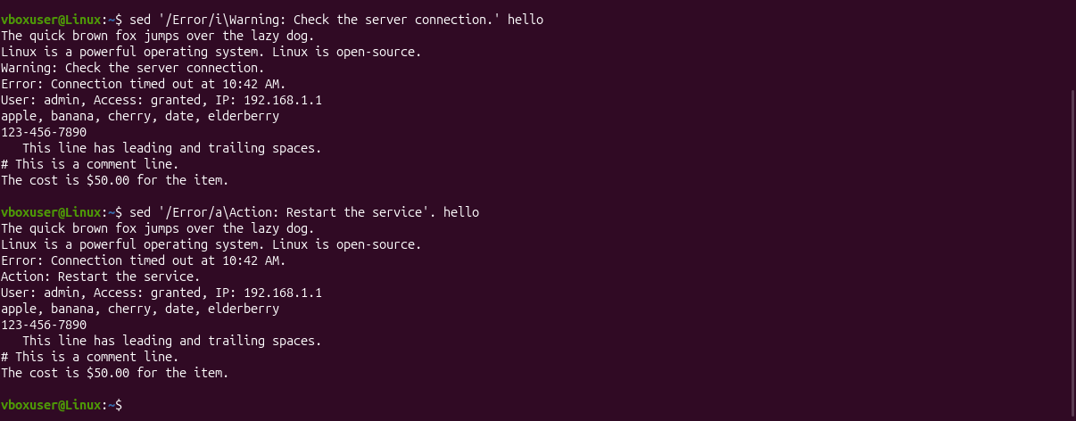

I used sed with i to insert text before a matching line and a to append text after a matching line.

40. Print only specific lines

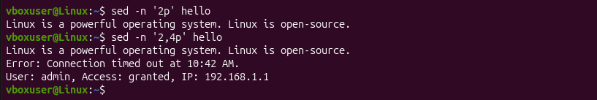

I used sed with the -n and p options to print only the required lines instead of displaying the complete file.
41. Copy a file from Linux to Windows
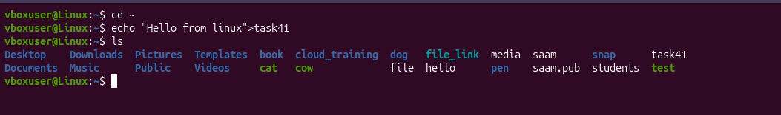
I used scp to securely copy a file from the Linux machine to a Windows machine over SSH.

42. Five SED use cases
I used sed to search for the word Linux and replace it with Ubuntu. The g option replaces all occurrences in each line.

I used sed with the d command to delete specific lines. The line can be selected using its line number or a matching pattern.
I used sed with i to insert text before a matching line and a to append text after a matching line.
I used sed with the -n and p options to print only the required lines instead of displaying the complete file.
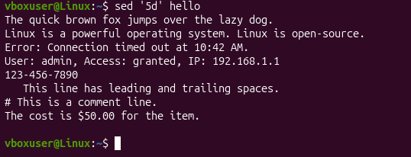
Delete a specific line by number
AWK Use cases -
I used awk to perform calculations

